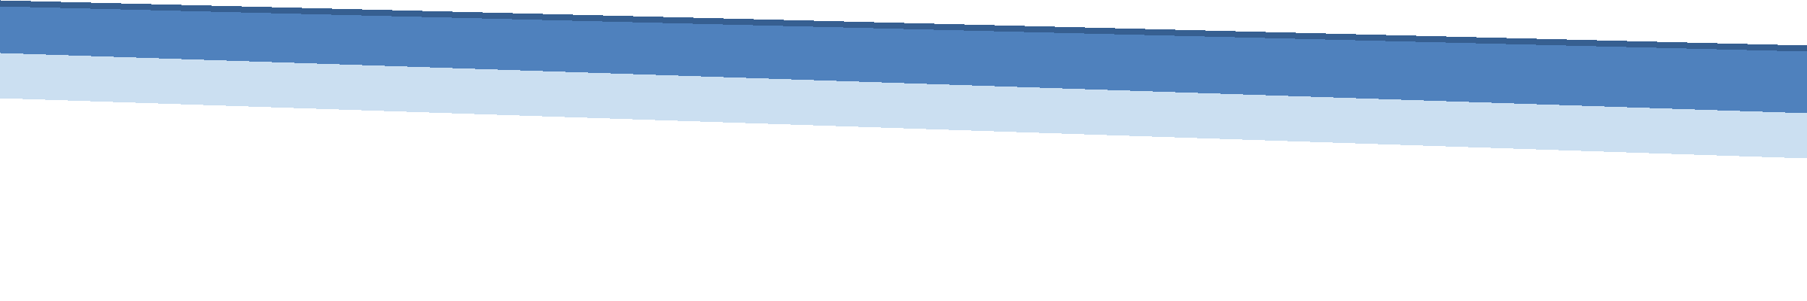

Week 8 Final Report
Final Incident Investigation Report
Case DFIR
Consolidating Weeks 1 through 7 of the DFIR Internship

Submitted By: Yusra Farooq
4September, 2026

Table of Contents
Executive Summary 3
1. Introduction & Internship Overview 4
2. Objectives of the Final Report 5
3. Methodology 5
3.1 Evidence-Handling Standards Applied Throughout 5
3.2 Digital Forensics Process Model (NIST-Aligned) 5
4. Case Overview: DFIR-2026-0714 6
4.1 Entities Involved 6
5. Scope Determination: In-Scope vs. Skills-Exercise Weeks 7
6. Consolidated Master Timeline 8
7. Attack Chain & Infrastructure Mapping 10
8. Evidence & Findings by Source Week 11
9. Consolidated Indicators of Compromise (IOC) 13
10. Root Cause Analysis 14
11. Impact Assessment 15
12. Incident Response Lifecycle Mapping (NIST SP 800-61) 16
13. Recommendations 17
14. Skills-Development Weeks (Out of Case Scope) 18
15. Tools Used Across the Internship 19
16. Consolidated Evidence Hash Manifest 20
17. Challenges Faced & Solutions Implemented 21
18. Learning Outcomes Achieved 22
19. Conclusion 23
References 24
Appendix A: Weekly Deliverables Index 25
GitHub Repository
github.com/yusrafarooq112233/Digital-Forensics-Incident-Response

Executive Summary
This report is the Week 8 capstone deliverable of the Digital Forensics & Incident Response (DFIR) internship. It consolidates seven weeks of investigative and skills-building work into a single, defensible incident investigation report for Case DFIR-2026-0714.
Four of the seven prior weeks 1, 4, 5, and 6 independently examined different pieces of evidence tied to the same case: an original credential-harvesting phishing email (Week 1), the browser and email artifacts showing that email's link being clicked alongside a second, malware-delivering email (Week 4), a live memory capture showing the same command-and-control infrastructure still active nearly a month later (Week 5), and a second phishing wave reusing the same infrastructure against a different employee (Week 6). Individually, each week told only part of the story. Merged and normalized into one timeline (Week 7), they reveal a single continuing campaign rather than four unrelated incidents.
Two other weeks Week 2 (disk imaging) and Week 3 (Windows Event Log analysis) were deliberately excluded from this case narrative. They were procedural skills exercises performed against separate, unrelated evidence sets, and are reported here as internship skill development rather than case evidence, consistent with the scoping discipline documented in Week 7.
This report presents the consolidated timeline, the full indicator-of-compromise (IOC) set, root cause analysis, business impact, and a mapping of the incident against the four phases of the NIST SP 800-61 incident response lifecycle, together with concrete containment, eradication, recovery, and post-incident recommendations.
Field | Summary
Case ID | DFIR-2026-0714
Campaign duration observed | 13 Jul 2026 – 19 Aug 2026 (5 weeks, still active at last observation)
Employees targeted | m.tariq@nexbank-corp.com, h.tariq@ corp.com
Core infrastructure | 185.220.101.0/24; secure-it-service.net; mail-secure-portal.com; freegiftcards-claim.net
Confirmed impact | 1 credential compromised (admin_backup); persistent C2 channel; 1 malicious executable downloaded
Current IR phase | Detection & Analysis complete; Containment/Eradication/Recovery and Post-Incident Activity not yet performed

1. Introduction & Overview
Over seven weeks, this internship progressed from foundational evidence-handling discipline through acquisition and analysis of successive evidence types, concluding with the consolidation exercise this report builds on. The table below summarizes each week's focus and its relationship to Case DFIR-2026-0714.
Week | Focus | Key Activity | Relationship to the Case
1 | Evidence Acquisition & Hashing | Phishing email header/IOC analysis; Chain of Custody; SHA-256/MD5 hashing | In scope opens the case
2 | Disk Imaging & Examination | Purpose-built evidence disk imaged and examined with dd, The Sleuth Kit, Autopsy | Skills exercise unrelated case
3 | Windows Event Log Analysis | Event Viewer, PowerShell (Get-WinEvent), wevtutil on an unrelated host | Skills exercise unrelated host
4 | Browser & Email Forensics | Chrome History (sqlite3) and second phishing email correlated to Week 1 | In scope confirms same campaign
5 | Memory Forensics | Live process memory acquisition (gcore); C2 IP and stolen credential recovered | In scope same C2 IP as Weeks 1 & 4
6 | Phishing & Malware Indicators | Second-wave phishing email; static IOC extraction from attachment | In scope same infrastructure, new target
7 | IR Lifecycle & Timeline Creation | Consolidated Weeks 1, 4, 5, 6 into one master timeline; scoped out Weeks 2 & 3 | Consolidation of the case
8 | Final Investigation Report (this document) | Full case narrative, IOC consolidation, impact, recommendations, final presentation | Capstone deliverable

2. Objectives
- Consolidate all case-relevant findings from Weeks 1, 4, 5, and 6 into a single, coherent incident narrative.
- Present the full, correlated Indicator of Compromise (IOC) set in a single reference table suitable for blocklisting or threat-intel sharing.
- State explicitly, with justification, which prior weeks are in scope for this case and which are not.
- Perform root cause and business impact analysis for Case DFIR-2026-0714.
- Map the incident against every phase of the NIST SP 800-61 incident response lifecycle, including the two phases not yet carried out.
- Provide concrete, actionable containment, eradication, recovery, and post-incident recommendations.
- Summarize tools, challenges, and learning outcomes across the full internship.
- Prepare the accompanying final presentation summarizing this report for a briefing.

3. Methodology
This report was produced by re-reading Weeks 1 through 6 in full, rather than relying on summaries alone, in order to catch cross-week indicators that no single week's author would have had reason to notice at the time. The methodology follows the same evidentiary discipline established in Week 1 and applied consistently since:

3.1 Evidence-Handling Standards Applied Throughout
- Order of Volatility: evidence was always collected starting with what disappears fastest (live memory, Week 5) before less volatile sources.
- Chain of Custody: every acquisition was logged, and originals were never analyzed directly; forensic working copies were used and hash-verified against the original.
- Hashing at acquisition: every evidence file was hashed (SHA-256, and MD5 where noted) at the moment of preservation, before any analysis began.
- Timestamp confidence: every timeline event is tagged Exact (taken directly from source evidence) or Approximate (reasonably inferred), never presented as falsely precise.
- Explicit scoping: evidence was only merged into the case narrative after checking it against shared case identifiers, hostnames, domains, or IP addresses.

3.2 Digital Forensics Process Model (NIST-Aligned)
- Identification: recognizing an incident occurred and locating evidence sources.
- Preservation: securing evidence so it cannot be altered.
- Collection: acquiring evidence in a forensically sound manner.
- Examination: extracting relevant data from acquired evidence.
- Analysis: interpreting extracted data to answer investigative questions.
- Presentation: reporting findings clearly, in a form that holds up under scrutiny (this report).

4. Case Overview: DFIR-2026-0714
This starts with a credential-harvesting phishing email was received at m.tariq@nexbank-corp.com, disguised as an IT Service Desk mailbox-storage warning. Within the same session, the recipient's browser history shows the embedded verification link being clicked, followed shortly after by a second, reward-themed phishing email carrying a disguised executable attachment (Q2_Invoice.pdf.exe), and a subsequent hidden network connection to a raw external IP address. Nearly a month later, live memory forensics on a related workstation recovered that exact same command-and-control IP address still active, alongside a stolen administrative credential and an exfiltration marker. On 19 August 2026, a second wave of the same phishing infrastructure now from an IP in the same /24 block was sent to a second NexBank employee, and static analysis of its attachment recovered matching command-and-control, mutex, and persistence indicators.
Read together, these four weeks of evidence describe a single, continuing campaign not four unrelated incidents. That correlation is the central finding of this internship and is presented in full in Section 8.

4.1 Entities Involved
Entity | Value
Victim organization | NexBank Corp
Targeted employees | m.tariq@nexbank-corp.com (Wave 1); h.tariq@nexbank-corp.com (Wave 2)
Lure identity | "IT Service Desk" / "NexBank IT Support" (impersonated internal helpdesk)
Sending domains | secure-it-service.net; freegiftcards-claim.net
Credential-harvesting domain | mail-secure-portal.com
Sending / relay IPs | 185.220.101.47 (Wave 1 + C2); 185.220.101.62 (Wave 2) — same /24 block
Malicious attachment (Wave 1/4) | Q2_Invoice.pdf.exe
Malicious attachment (Wave 2/6) | Mailbox_Storage_Report.xlsm
Compromised credential | admin_backup : P@ssw0rd2026!

5. Scope Determination: In-Scope vs. Skills Exercise Weeks
Not every internship exercise belongs to the same case. Before any evidence was merged into a single narrative, each week was checked against two criteria: whether it shares a case identifier, workstation, domain, IP, or user with the others, and whether its own evidence stands independent of that context. The results of that check:
Week | Case ID / Context | Status | Basis for Decision
1 | DFIR-2026-0714 | In scope | Opens the case (m.tariq, secure-it-service.net, 185.220.101.47)
2 | CF-2026-W2-DI01 | Out of scope | Purpose-built disk-imaging exercise; no shared indicators
3 | (unrelated host) | Out of scope | Windows Event Log analysis on an unrelated host; no shared indicators
4 | DFIR-2026-0714 (implied) | In scope | Same NexBank workstation as Week 1; same domains/IP
5 | DFIR-2026-0714 (implied) | In scope | Recovers the exact C2 IP from Weeks 1 & 4 in live memory
6 | DFIR-2026-0714 (implied) | In scope | Same lure domain/IP block as Week 4, against a new target

Weeks 2 and 3 are documented in Section 14 as skills-development work rather than omitted silently an explicitly-recorded exclusion is part of a defensible investigation, not a gap in it.

6. Consolidated Master Timeline
The eleven events below were extracted from Weeks 1, 4, 5, and 6, normalized to a common date/time format, tagged with MITRE ATT&CK tactics, and sorted chronologically. Full detail, including timestamp-confidence flags and column filtering, is maintained in the companion workbook Master_Timeline.xlsx
SHA-256: fedd491471a2072ef5c9c4ac8db3e800a50a1f80b5d62d606a3e99aae57ccbef

Date | Source | Event | MITRE ATT&CK Tactic
13 Jul 2026 | Week 1 | Credential-harvesting phishing email received (secure-it-service.net; IP 185.220.101.47) | Initial Access
13 Jul 2026 | Week 4 | Gmail opened (baseline) | Baseline
13 Jul 2026 | Week 4 | NexBank employee portal visited (baseline) | Baseline
13 Jul 2026 | Week 4 | Week 1 verification link clicked (mail-secure-portal.com) | Initial Access
13 Jul 2026 | Week 4 | Second phishing email received, Q2_Invoice.pdf.exe attached | Initial Access
13 Jul 2026 | Week 4 | Reward/lure link visited (freegiftcards-claim.net) | Initial Access
13 Jul 2026 | Week 4 | Q2_Invoice.pdf.exe downloaded, flagged dangerous | Execution
13 Jul 2026 | Week 4 | Hidden connection to raw IP 185.220.101.47 | Command and Control
12 Aug 2026 | Week 5 | Live memory: same C2 IP, stolen credential, exfil marker | C2 / Credential Access
19 Aug 2026 | Week 6 | Second-wave phishing email received (h.tariq) | Initial Access
19 Aug 2026 | Week 6 | Static analysis recovers matching C2/mutex/persistence IOCs | Discovery (Analyst)
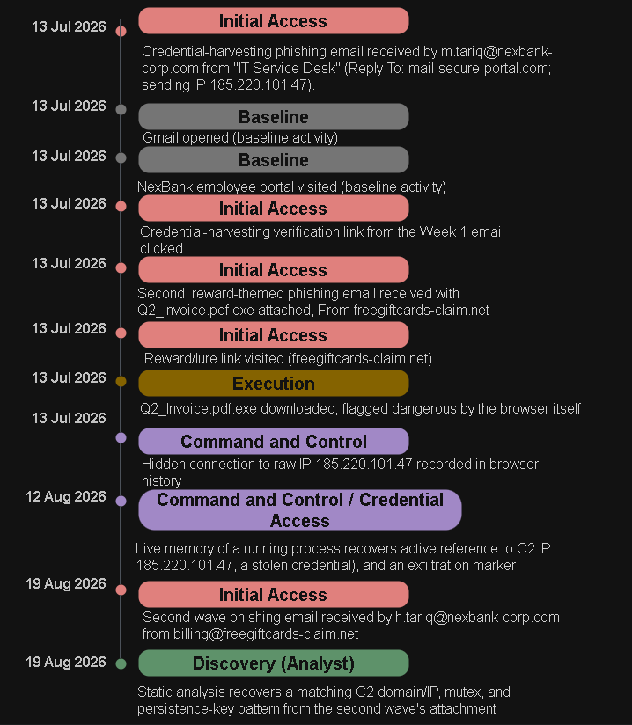

Figure 1.1. Visual master timeline of Case DFIR-2026-0714, color-coded by MITRE ATT&CK tactic (source: Week 7).
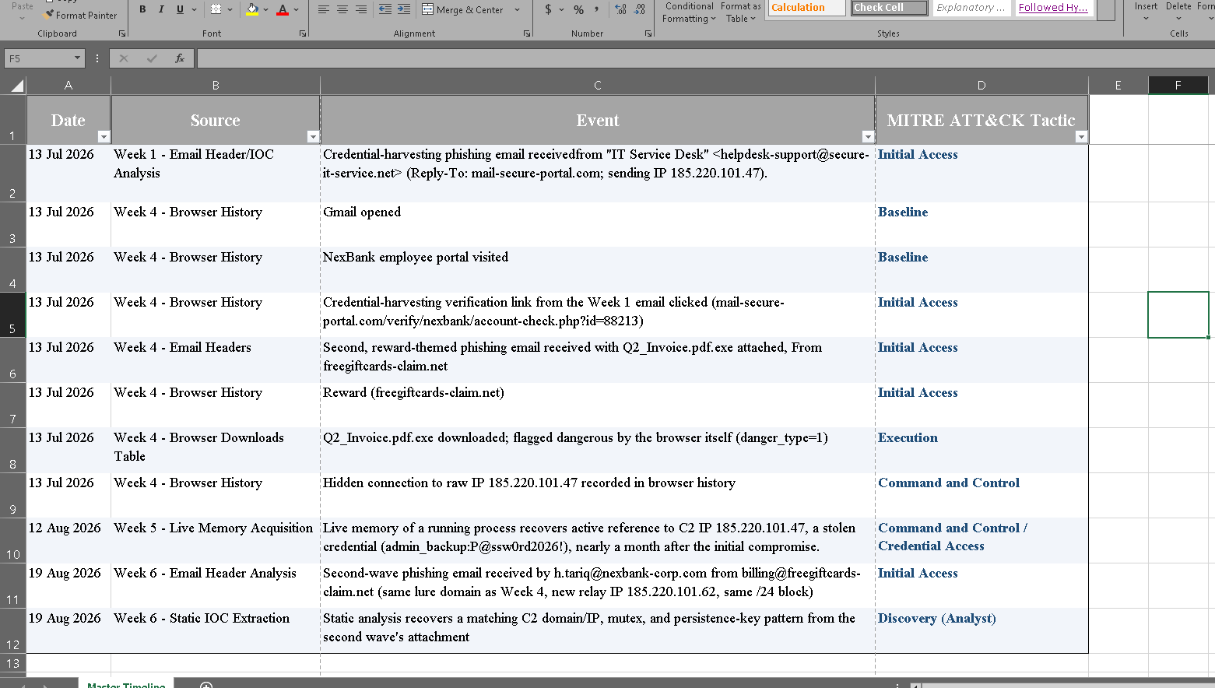
Figure 1.2. master timeline of Case DFIR-2026-0714
The shape of the campaign is visible only once all four sources are merged: a tight, single-morning compromise cluster on 13 July, a nearly five-week silence, then confirmation on 12 August that the same C2 channel remained live, followed by a second wave against a new target on 19 August. No individual week's report surfaced this pattern on its own.

7. Attack Chain & Infrastructure Mapping
The following diagram aligns the five key stages of the campaign to MITRE ATT&CK tactics, showing how the investigation moved from initial access through to the discovery of the second wave.
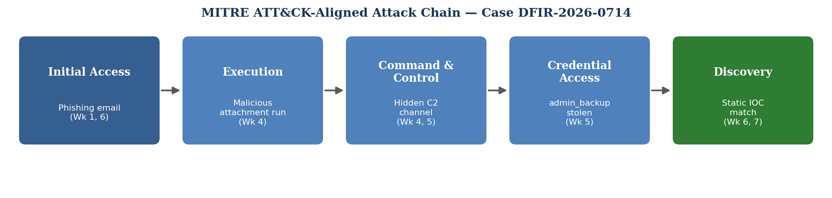
Figure 2. Attack chain for Case DFIR-2026-0714, mapped to MITRE ATT&CK tactics.
The diagram below maps how the same attacker infrastructure was reused across both phishing waves, and where each indicator was first recovered.

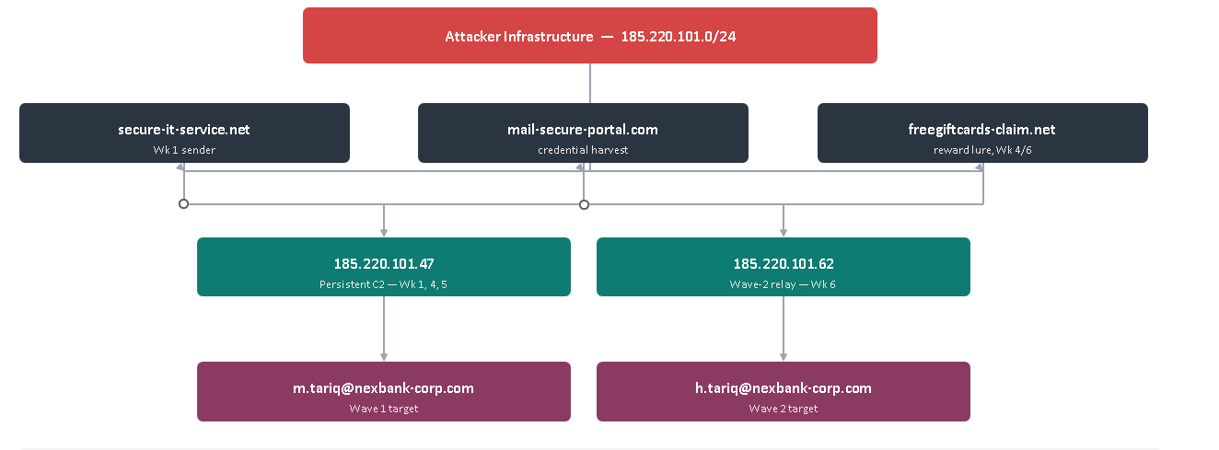
Figure 3. Infrastructure relationship map domains, IPs, and targeted employees across both waves.

MITRE ATT&CK Tactic Summary
Tactic | Technique Observed | Evidence
Initial Access | Spear phishing Link / Spear phishing Attachment (T1566) | Weeks 1, 4, 6
Execution | User Execution: Malicious File (T1204.002) | Week 4
Persistence | Registry Run Keys (T1547.001) | Week 6
Command and Control | Non-Application Layer Protocol / raw IP contact (T1095, indicative) | Weeks 4, 5
Credential Access | Unsecured Credentials in memory (T1552, indicative) | Week 5
Discovery (analyst-side) | Static/behavioral indicator extraction | Week 6

8. Evidence & Findings by Source Week

8.1 Week 1 — Original Phishing Email (Initial Access)

The case opened with a credential-harvesting phishing email received at m.tariq@nexbank-corp.com on 13 July 2026, claiming the mailbox had exceeded its storage quota and pressuring the recipient to “verify” their account via an external link. Header analysis (grep against the raw .eml file) recovered a sender domain (secure-it-service.net) that did not match the Reply-To domain (mail-secure-portal.com) a classic mismatch indicator and a originating IP (185.220.101.47) with no legitimate relationship to NexBank's infrastructure. The evidence file was hashed:
SHA-256 :22fd1dd31ddce6bc22a9066836f2f5db2cea589d1e10476dced920d4e1f07fb

Field | Value
From | "IT Service Desk" <helpdesk-support@secure-it-service.net>
Reply-To | it.recovery@mail-secure-portal.com (domain mismatch)
Sending IP | 185.220.101.47 (external, unverified relay)
Authentication | SPF fail; DKIM none; DMARC fail (quarantine)
Embedded URL | http://mail-secure-portal.com/verify/nexbank/account-check.php?id=88213
Evidence SHA-256 | 22fd1dd31ddce6bc22a9066836f2f5db2cea589d1e10476dced920d4e1f07fb

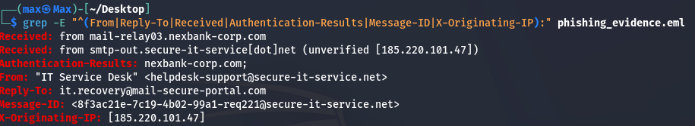

8.2 Week 4 Browser History & Second Phishing Email
Indicator | Seen In | Value
Malicious domain | Browser history + Email Reply-To | mail-secure-portal.com
Reward/lure domain | Browser history + Email From | freegiftcards-claim.net
Raw-IP contact | Browser history (hidden entry) | 185.220.101.47
Disguised download | Browser downloads table | Q2_Invoice.pdf.exe (danger_type=1, flagged)
Attachment SHA-256 | Extracted from email | 43b8a8b139364d3934c58dc25dadc87536f719b802f18dca3e66b73b5448bd0f

Chrome History database and a second phishing email recovered from the same NexBank workstation confirmed that the Week 1 link was not just delivered it was clicked. Querying the browser's downloads table directly showed the disguised executable Q2_Invoice.pdf.exe being downloaded from freegiftcards-claim.net and flagged dangerous by the browser itself (danger_type=1), alongside a legitimate payroll_report.xlsx download for contrast. The second email's headers again showed a Reply-To mismatch pointing back to mail-secure-portal.com the same domain from Week 1.

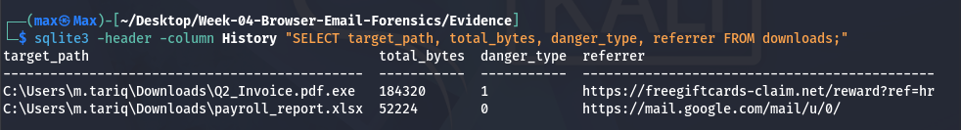

8.3 Week 5 — Live Memory Forensics
A live memory capture
SHA-256: b905e493f99955b3e5eb983e4605a6af24c140618967a833de6ec3a18c536646
Hashed of a running process recovered plaintext evidence that the attacker's access had persisted and matured into active credential theft: the exact same C2 IP address from Week 1 and Week 4 (185.220.101.47), a stolen administrator credential (admin_backup:P@ssw0rd2026!), and an exfiltration marker string (EXFIL_TOKEN_9f8a7b6c5d4e), none of which had ever been written to disk. This is the single most significant finding of the case: it proves the initial-access chain from July did not end at a flagged download it matured into a live, persistent compromise with a stolen credential in hand, undetected for weeks.
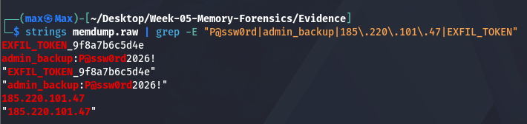

Artifact | Value | Source
C2 server IP | 185.220.101.47 | strings on memdump.raw
Stolen credential | admin_backup : P@ssw0rd2026! | strings on memdump.raw
Exfiltration marker | EXFIL_TOKEN_9f8a7b6c5d4e | strings on memdump.raw
Memory dump SHA-256 | b905e493f99955b3e5eb983e4605a6af24c140618967a833de6ec3a18c536646 | Computed at acquisition

The recurrence of 185.220.101.47 the exact sending IP from Week 1 as an active C2 address nearly a month later is the single strongest piece of evidence tying these weeks into one continuing incident rather than coincidence.

8.4 Week 6 — Second-Wave Phishing & Static Malware Indicators
On 19 August 2026, the same infrastructure resurfaced against a second employee, h.tariq@nexbank-corp.com, via a mailbox-storage-themed phishing email carrying a macro-enabled attachment (Mailbox_Storage_Report.xlsm). Safe static analysis of the attachment's dropper (strings and grep, without executing any code) recovered a full indicator set: C2 domain freegiftcards-claim.net (matching Week 4's lure domain exactly), a relay IP of 185.220.101.62 (in the same 185.220.101.0/24 block as the Week 1/4/5 IP), a named mutex a drop path and a beacon URI pattern (/api/v2/checkin?id=<hostid>). Email authentication failed across the board.
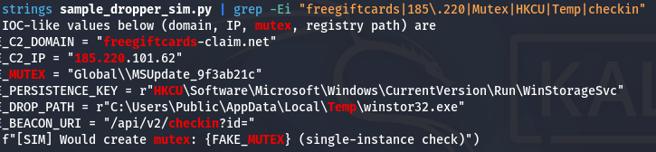

Indicator Type | Value | Source
Sender / relay domain | freegiftcards-claim.net | Email headers
Relay / C2 IP | 185.220.101.62 (same /24 as Week 5's C2) | Email headers & sample
Email authentication | SPF fail / DKIM none / DMARC fail | Email headers
Mutex | Global\MSUpdate_9f3ab21c | Static extraction
Persistence key | HKCU\Software\Microsoft\Windows\CurrentVersion\Run\WinStorageSvc | Static extraction
Drop path | C:\Users\Public\AppData\Local\Temp\winstor32.exe | Static extraction
Beacon URI pattern | /api/v2/checkin?id=<hostid> | Static extraction
Malicious attachment | Mailbox_Storage_Report.xlsm | Email attachment
Email SHA-256 | d0c4d87ec6458fb25737bd022277f86dd0cabbf2a68c5cb3ca35aebcb59a4e72 | Preservation
Sample SHA-256 | 2e1c425f36bc9e351487d1765fde35d70d38331e5d65e5dce839f1f56017d946 | Preservation

9. Consolidated Indicators of Compromise (IOC)
The full IOC set recovered across Weeks 1, 4, 5, and 6, consolidated into one reference table suitable for blocklisting or threat-intelligence sharing:
Type | Value | Context | Wk
Domain | secure-it-service.net | Wave 1 sender domain | 1
Domain | mail-secure-portal.com | Wave 1 credential-harvesting domain | 1, 4
Domain | freegiftcards-claim.net | Wave 1b / Wave 2 lure domain | 4, 6
IP address | 185.220.101.47 | Wave 1 sending IP; persistent C2 | 1, 4, 5
IP address | 185.220.101.62 | Wave 2 relay IP (same /24 block) | 6
URL | mail-secure-portal.com/verify/nexbank/account-check.php?id=88213 | Credential-harvesting link | 1, 4
File | Q2_Invoice.pdf.exe | Wave 1 malicious executable | 4
File | Mailbox_Storage_Report.xlsm | Wave 2 malicious macro attachment | 6
Mutex | Global\MSUpdate_9f3ab21c | Persistence/execution marker | 6
Registry key | HKCU\...\Run\WinStorageSvc | Persistence mechanism | 6
File path | C:\Users\Public\...\winstor32.exe | Drop location | 6
URI pattern | /api/v2/checkin?id=<hostid> | Beacon / C2 check-in | 6
Credential | admin_backup | Compromised administrative account | 5
String | EXFIL_TOKEN_9f8a7b6c5d4e | Exfiltration marker | 5

10. Root Cause Analysis
The initial access vector in both waves was the same: unauthenticated inbound email allowed to reach end users despite failing SPF, DKIM, and DMARC checks. NexBank's mail gateway recorded these failures (visible directly in the raw headers analyzed in Weeks 1 and 6) but did not act on them by rejecting or quarantining the message before delivery DMARC was only set to quarantine, not reject, and even that policy was evidently not enforced at the gateway.
Contributing factors identified across the investigation:
- No enforced DMARC reject policy, allowing spoofed/look-alike sender identities through to the inbox.
- End-user susceptibility to urgency-based social engineering the same tactic succeeded twice, five weeks apart, against two different employees.
- No network-level egress filtering that would have blocked or alerted on the raw-IP connection recorded in Week 4's browser history.
- A detection gap of roughly a month between the original compromise (13 Jul) and the point at which the C2 channel was actually discovered (12 Aug) the intrusion was not detected by any automated control during that window.
- Reuse of the same /24 IP block and phishing kit for the second wave suggests the attacker's infrastructure was never blocklisted after the first wave was identified.
11. Impact Assessment

Dimension | Severity | Basis
Confidentiality | High | One administrative credential (admin_backup) confirmed compromised and observed in live memory alongside an exfiltration marker.
Integrity | Medium | No confirmed unauthorized data modification identified in available evidence; risk remains while the credential is unrotated.
Availability | Low (so far) | No denial-of-service or destructive activity observed in any of the four in-scope weeks.
Persistence / dwell time | High | C2 channel confirmed active for at least ~30 days (13 Jul – 12 Aug) without detection.
Scope of targeting | Medium-High | Confirmed against two named employees; the reused infrastructure and second wave suggest a broader targeting intent.

12. Incident Response Lifecycle Mapping (NIST SP 800-61)
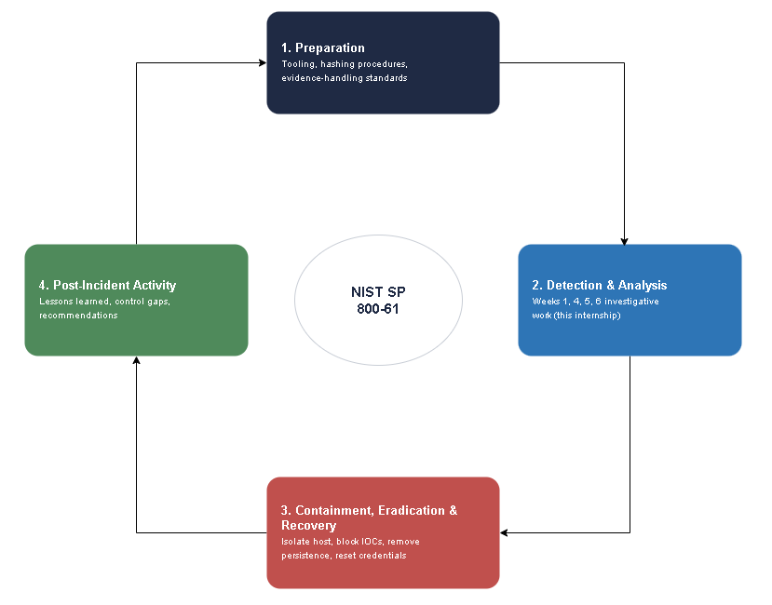
Figure 4. The NIST SP 800-61 incident response lifecycle mapped to this internship's work (source: Week 7).
Phase | Status | Detail
1. Preparation | Partially in place | Evidence-hashing and preservation procedures (Weeks 1 & 2) were followed correctly; email authentication enforcement was not, which is what allowed both phishing waves through.
2. Detection & Analysis | Complete | Weeks 1, 4, 5, and 6 together reconstructed the full attack chain from initial access through a live, persistent C2 connection and a second wave against a new target.
3. Containment, Eradication & Recovery | Not yet performed | See Section 13.1 for the specific recommended actions.
4. Post-Incident Activity | Not yet performed | See Section 13.2 for the specific recommended actions.

13. Recommendations

13.1 Containment, Eradication & Recovery
- Isolate the affected hosts the m.tariq and h.tariq workstations from the network pending rebuild.
- Block 185.220.101.0/24, secure-it-service.net, mail-secure-portal.com, and freegiftcards-claim.net at the firewall/DNS layer immediately.
- Reset credentials for m.tariq, h.tariq, and the exposed admin_backup account; audit admin_backup for any use since 12 Aug 2026.
- Rebuild affected hosts from a known-clean image rather than attempting in-place remediation, given confirmed persistence and an unresolved dwell time.
- Search email and endpoint logs organization-wide for the mutex, persistence key, drop path, and beacon URI pattern identified in Week 6.

13.2 Post-Incident Activity
- Document and formally close the detection gap between the 13 Jul compromise and the 12 Aug discovery.
- Enforce a DMARC reject policy (not quarantine) for inbound mail failing authentication.
- Add alerting for repeated contact to the same external IP address across sessions or hosts.
- Deliver phishing-awareness training referencing both lures used in this specific campaign.
- Formally blocklist infrastructure identified after Wave 1 to prevent its reuse its reuse in Wave 2 indicates this did not happen the first time.
14. Skills-Development Weeks (Out of Case Scope)
Weeks 2 and 3 are reported here for completeness as internship skill development. They are excluded from the case narrative above because they do not share a case identifier, host, domain, or IP with Case DFIR-2026-0714 (Section 5).

14.1 Week 2 — Disk Imaging & Examination (CF-2026-W2-DI01)
A purpose-built evidence set simulating a seized employee laptop was created, placed on a virtual disk, and imaged and examined using dd, The Sleuth Kit (fsstat, fls, icat), and Autopsy, without ever touching the evidence disk directly after acquisition.

14.2 Week 3 — Windows Event Log Analysis
Live system logs on an unrelated Windows 11 host were examined directly through Event Viewer, PowerShell (Get-WinEvent), and wevtutil, covering the Security, System, and Application logs, custom views, and forensic timeline-building from exported logs.

15. Tools Used Across the Internship
Tool | Used in Week(s) | Purpose
VirtualBox | 1 | Isolated VM lab for tool installation
sha256sum / md5sum | 1, 2, 4, 5, 6, 7 | Evidence integrity hashing at acquisition and verification
Linux shell / grep | 1, 4, 6 | Header extraction, IOC pattern matching
Excel | 1, 7 | Chain of Custody form; consolidated master timeline workbook
dd, mkfs.ext4, losetup/mount | 2 | Raw disk container creation, formatting, and mounting
The Sleuth Kit (fsstat, fls, icat) | 2 | Filesystem examination without mounting
Autopsy | 2 | Graphical forensic suite built on The Sleuth Kit
Event Viewer, PowerShell, wevtutil | 3 | Windows Event Log browsing, querying, and export
sqlite3, python3 | 4 | Chrome History querying; timestamp conversion; MIME parsing
gcore (GDB) | 5 | Live process memory acquisition
strings, Volatility 3 | 5, 6 | Raw memory / static string extraction and analysis
Microsoft Excel (visual timeline) | 7 | Timeline visualization and MITRE ATT&CK tagging

16. Consolidated Evidence Hash Manifest
Every evidence and deliverable file referenced in this report was hashed at the point of acquisition or generation. This consolidated manifest allows independent verification of every artifact's integrity without re-deriving values scattered across seven reports.
File | Source Week | SHA-256
phishing_evidence.eml | Week 1 | 22fd1dd31ddce6bc22a9066836f2f5db2cea589d1e10476dced920d4e1f07fb
Q2_Invoice.pdf.exe | Week 4 | 43b8a8b139364d3934c58dc25dadc87536f719b802f18dca3e66b73b5448bd0f
memdump.raw | Week 5 | b905e493f99955b3e5eb983e4605a6af24c140618967a833de6ec3a18c536646
phishing_storage_alert.eml | Week 6 | d0c4d87ec6458fb25737bd022277f86dd0cabbf2a68c5cb3ca35aebcb59a4e72
sample_dropper_sim.py | Week 6 | 2e1c425f36bc9e351487d1765fde35d70d38331e5d65e5dce839f1f56017d946
Master_Timeline.xlsx | Week 7 | fedd491471a2072ef5c9c4ac8db3e800a50a1f80b5d62d606a3e99aae57ccbef

17. Challenges Faced & Solutions Implemented
Challenge | Solution
Not every timestamp source recorded an exact time | Tagged affected events Approximate rather than inventing false precision
Determining which of six prior weeks genuinely belonged to one case | Checked every week against shared case IDs, hostnames, domains, and IPs before merging
Needed realistic evidence without handling live malicious code | Constructed technically accurate simulated phishing emails and artifacts, safely
A flat event table made the campaign's shape hard to see | Built a color-coded visual timeline and attack-chain diagram alongside the table
Findings scattered across seven separate reports | Consolidated every hash, IOC, and finding into single reference tables (Sections 9, 15, 16)

18. Learning Outcomes Achieved

- Can apply the six-stage digital forensics process model and NIST SP 800-61 incident response lifecycle to a real, multi-week investigation.
- Can build and maintain a defensible Chain of Custody, with cryptographic hashing at every acquisition and verification step.
- Can acquire and examine disk images, live memory, browser artifacts, and email evidence using industry-standard tools.
- Can extract and interpret email headers, static file indicators, and Windows Event Logs to identify malicious activity.
- Can correctly scope a multi-source investigation: merge evidence that belongs to one case, and explicitly exclude evidence that does not.
- Can normalize and correlate timestamps from independent evidence sources into one timeline, preserving honest confidence levels.
- Can tag events with MITRE ATT&CK tactics and map a reconstructed incident against every phase of a formal IR lifecycle.
- Can translate technical findings into prioritized, actionable recommendations for stakeholders.

19. Conclusion

This internship's seven weeks of work, consolidated here, tell a single coherent story: a credential-harvesting email opened Case DFIR-2026-0714 on the morning of 13 July 2026; a second, malware-carrying email followed within roughly two hours, delivering an executable that established a hidden connection to a raw external IP; that exact connection was found still active in live memory nearly a month later, alongside a stolen administrative credential; and the same attacker infrastructure resurfaced in August against a second employee. No single week's evidence showed this full picture it only became visible once every source was correlated, scoped correctly, and placed on one timeline.
The Detection & Analysis phase of the NIST SP 800-61 lifecycle is now complete for this incident. Containment, Eradication, Recovery, and Post-Incident Activity detailed in Section 13remain outstanding and are the organization's immediate next steps.

References
- NIST Special Publication 800-61 Rev. 2. Computer Security Incident Handling Guide. https://nvlpubs.nist.gov/nistpubs/SpecialPublications/NIST.SP.800-61r2.pdf
- MITRE ATT&CK®. Enterprise Matrix — Tactics & Techniques. https://attack.mitre.org/
- RFC 5322. Internet Message Format (email header structure). https://www.rfc-editor.org/rfc/rfc5322
- The Sleuth Kit & Autopsy Documentation. Digital forensics tooling reference. https://www.sleuthkit.org/
- Volatility Foundation. Volatility 3 Memory Forensics Framework. https://volatilityfoundation.org/
- FIRST.org. Chain of Custody & Evidence Handling Best Practices. https://www.first.org/

Appendix A: Weekly Deliverables Index
Week | Deliverable File(s) | Contents
1 | Week1_DFIR_Report.docx | Evidence Acquisition & Hashing; phishing_evidence.eml
2 | Week2_DFIR_Report.docx | Disk Imaging & Examination; virtual disk image
3 | Week3_DFIR_Report.docx | Windows Event Log Analysis
4 | Week4_DFIR_Report.docx | Browser & Email Forensics; Week4_DFIR_Lab_Evidence_Pack.zip
5 | Week5_DFIR_Report.docx | Memory Forensics; suspicious_process.py, HASHES.txt
6 | Week6_DFIR_Report.docx | Phishing & Malware Indicators; phishing_storage_alert.eml
7 | Week7_DFIR_Report.docx | IR Lifecycle & Timeline Creation; Master_Timeline.xlsx
8 | This report + Final Presentation | Final Incident Investigation Report and stakeholder briefing deck
Full source reports, scripts, and evidence packs for every week are maintained in the internship GitHub repository:
github.com/yusrafarooq112233/Digital-Forensics-Incident-Response

